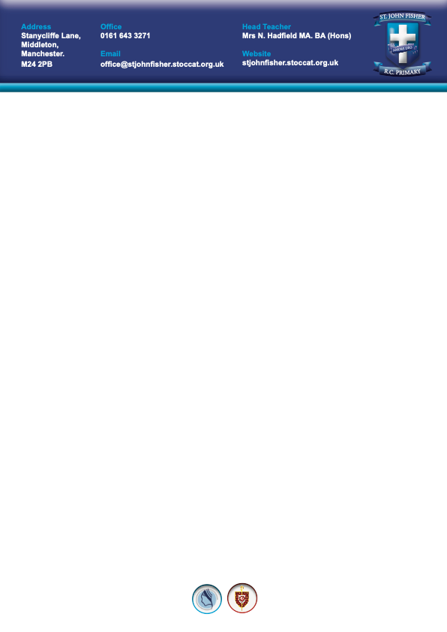
Wednesday 20 May 2026

Dear Parent/Guardian,

I am delighted to tell you that our school are taking part in a Greater Manchester tooth brushing programme to strengthen children’s teeth. This involves your child brushing their own teeth, using a fluoride toothpaste at school. This will be happening in your child’s class and I invite your child to take part.

Supervised tooth brushing in early year’s settings has been shown to be effective at reducing tooth decay in children. Each child taking part will receive a free toothbrush and toothpaste to use in their class under the supervision of the school staff. Your child will also receive a dental pack to take home containing a toothbrush, fluoride toothpaste and an information leaflet.

The aim of the programme is to help reduce dental decay in children and with your support we can reinforce your home tooth brushing routine. You can continue to brush your child’s teeth morning and night and to supervise their tooth brushing until he/she is 7 years old.

For your child to take part in this activity in school, you will need to give your consent by signing the tear off slip below and returning it to school. If you don’t return the slip your child won’t be able to benefit from this programme.

Yours sincerely,

Mrs N Hadfield
(Headteacher)

Please sign the slip below and return to school as soon as possible, to give your consent

……………………………………………………………………………………………………………….

By signing this I confirm:

- I have read and understood the information provided and am happy for my child to take part. If I want to withdraw my child I can inform the school in writing at any time.

Name: __________________________________________________ Childs Class: Reception

Signature of parent/guardian ______________________________ Date ________________

